1. JAR Files (Java Archive)
- What it is: A single file (like a ZIP folder) that bundles all your Java program's parts (.class files, images, etc.).
- Why use it: Makes it easy to distribute and run your program.
- The Manifest File:
  - A small text file inside the JAR that gives instructions.
  - Tells Java where the main method is (Main-Class).
  - Lists other JAR files your program needs (Class-Path).
- How to Create a JAR:
  - First, create a manifest file.
  - Then use the command: jar cmf myManifest.txt MyApp.jar *.class
    - c = create
    - m = use my manifest file
    - f = the JAR file name
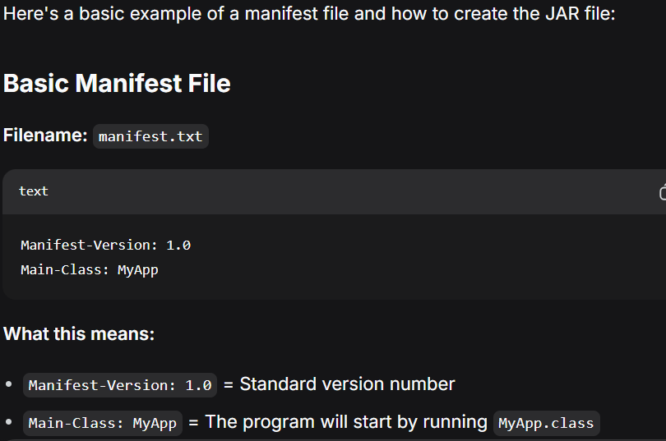
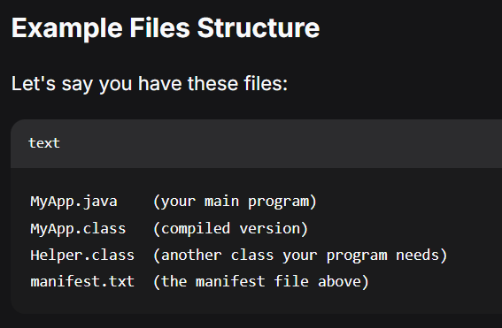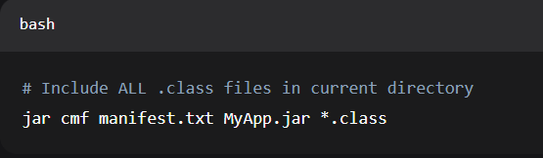

2. Signing & Verifying JARs (Security)
- Why: To prove the JAR file is from a trusted person and hasn't been changed by a virus.
- How it Works:
  - Create a Key: Use keytool to make a digital signature (like a unique stamp).
  - Sign the JAR: Use jarsigner to "stamp" your JAR file with your signature.
  - Verify: The user can run jarsigner -verify MyApp.jar to check the stamp is valid.
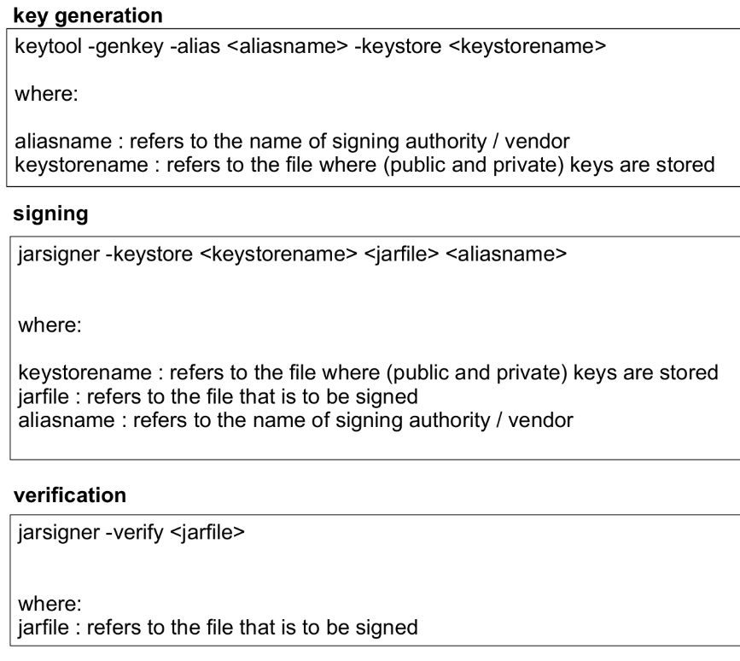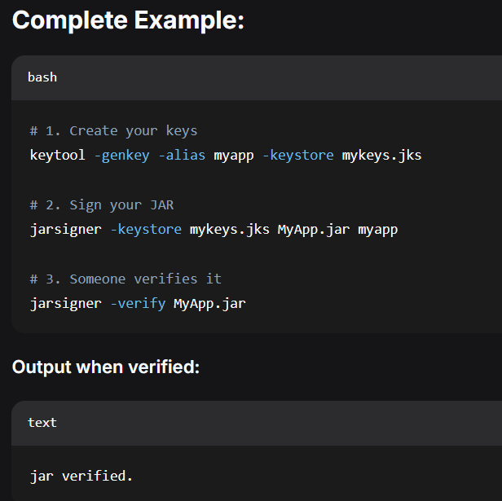

3. Deploying Your App (Getting it to Users)
- Ask Yourself:
  - Is it a desktop app, a web app, or a mobile app?
  - Where will it live? (User's computer, a cloud server?)
  - How will it update? (Automatically? Manually?)
- Tools for Desktop Apps:
- Launch4j: Turns your JAR into a Windows .exe for desktop - users download and install it on their computer
- Java Web Start: Lets users run your desktop app by clicking a web link - it downloads and runs on their computer (not in browser)
- Both are for DESKTOP apps - they just provide different ways to launch your Java desktop application

4. Distribution & Release
- Where to Share Your App:
  - Public Repositories: Like an "app store for code." Examples: Maven Central, GitHub.
  - App Stores: Google Play, Apple App Store, Microsoft Store.
- Release Management (The Plan):
  - A checklist to make sure your app is ready for the public.
  - Steps include: finishing features, testing (QA), writing manuals, and packaging the final files.

5. Javadoc (Auto-Generated Documentation)
- What it is: A tool that automatically creates a website with instructions for your code.
- How it works: It reads special comments you write in your code.
- How to use it: Run a command like:
javadoc -d docs -sourcepath src -subpackages com.myapp
  - This creates HTML documentation in a folder called docs.

